Note : If you are running 64 bit windows, you need to install Silk SVN first..Go to the following URL and click on 64 bit edition and install a typical version of Silk SVN..

URL to download Silk SVN from : http://www.sliksvn.com/en/download

If you are wondering why you need Silk SVN for 64 bit windows, read this : http://subclipse.tigris.org/wiki/JavaHL ( I would recommend not to waste your time reading this..just skip this reading).

Now, go to your eclipse Help --> Install New Software...screenshot below

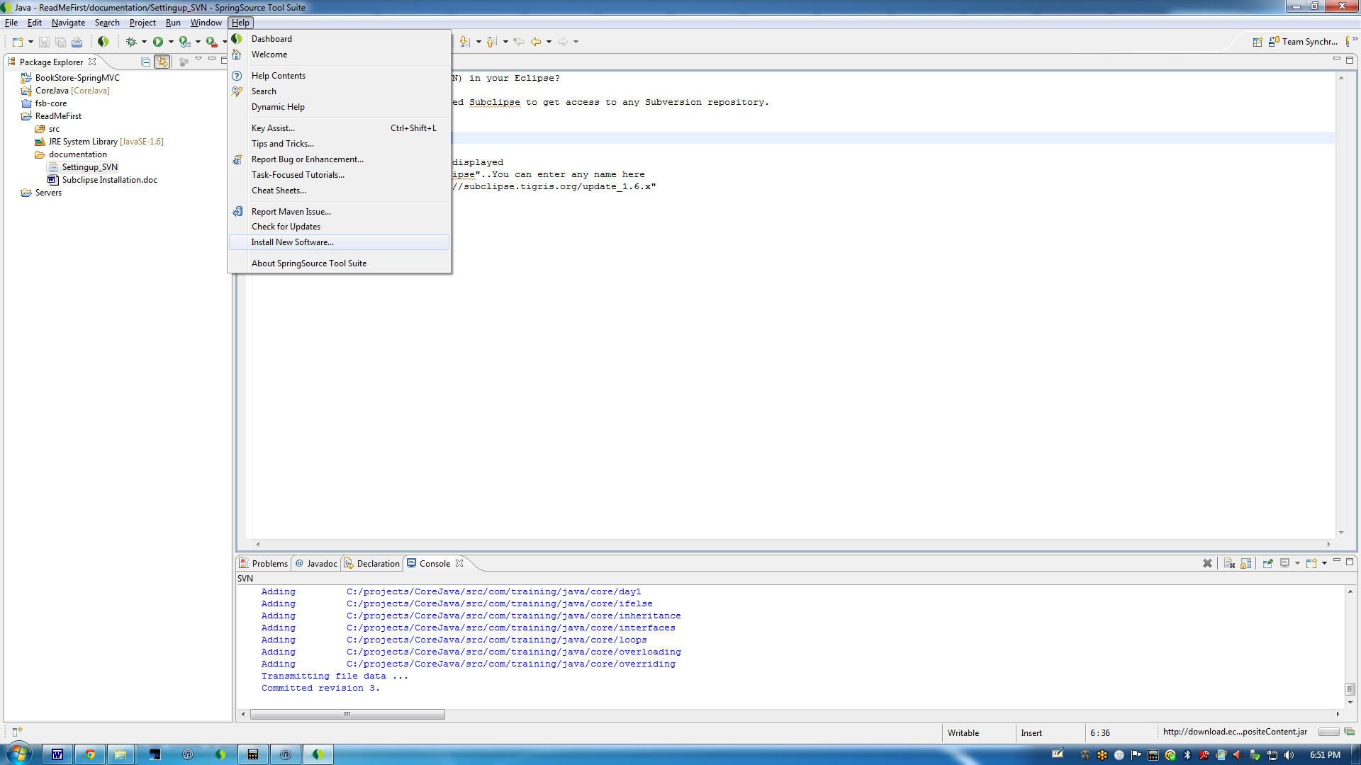

Now, click on Add button and in the name field, enter "Subclipse"..You can enter any name here... In Location field, enter "http://subclipse.tigris.org/update_1.6.x"..Now, click ok..Then, you will see the following screen..Click on "Select All" button and click "Enter"..

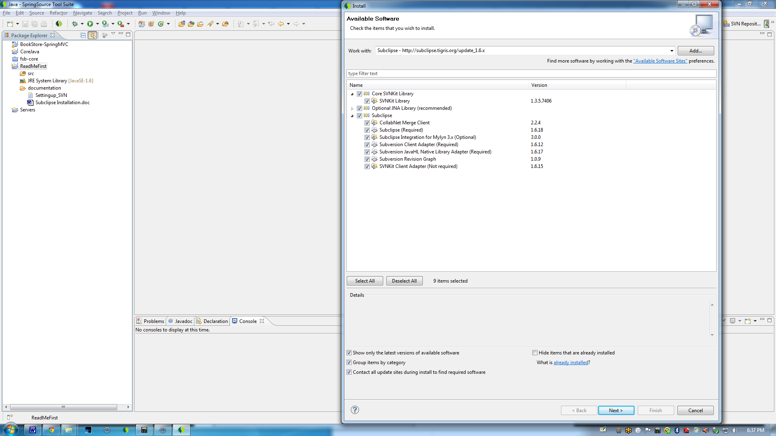

Now, you will see the following screen..

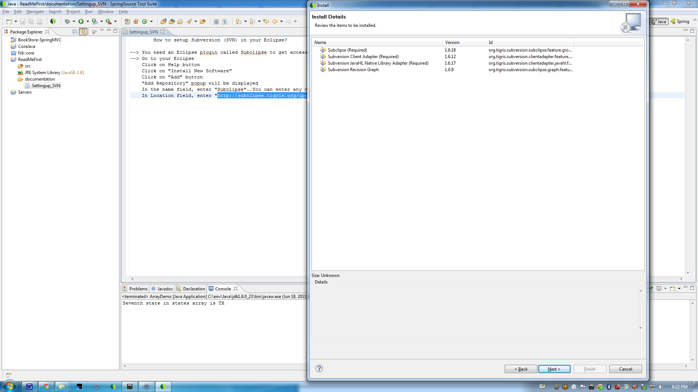

Click next, then you will see the following screen
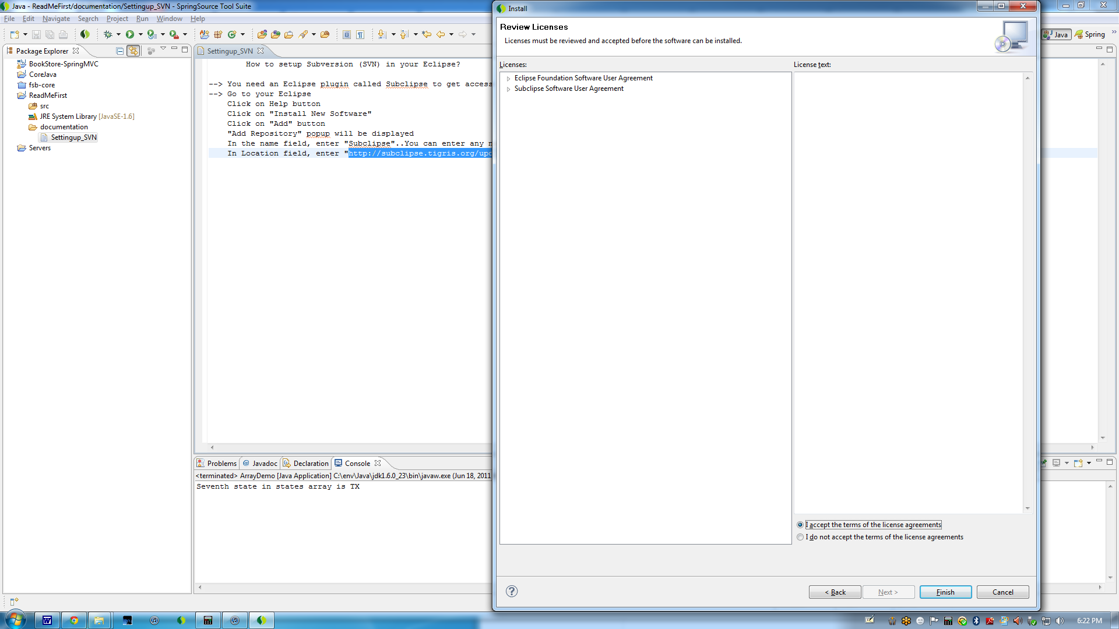

Now click on "I accept the terms of the license agreement" and click on Finish button

After some time, you will see the following warning message..Click on ok button..
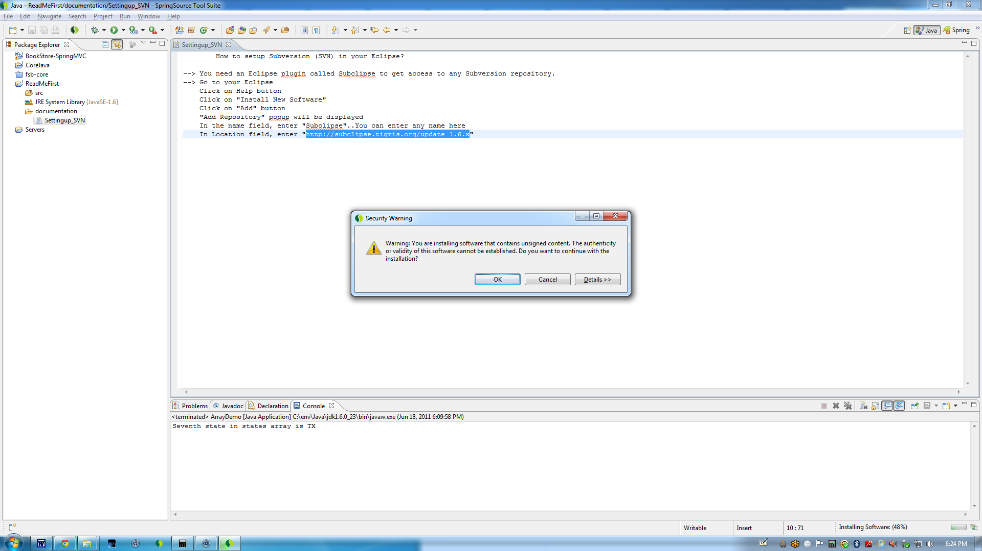

Now, it will install the software. After installation, you will see the following screen to restart the Eclipse..Click on Yes, it will restart the Eclipse.

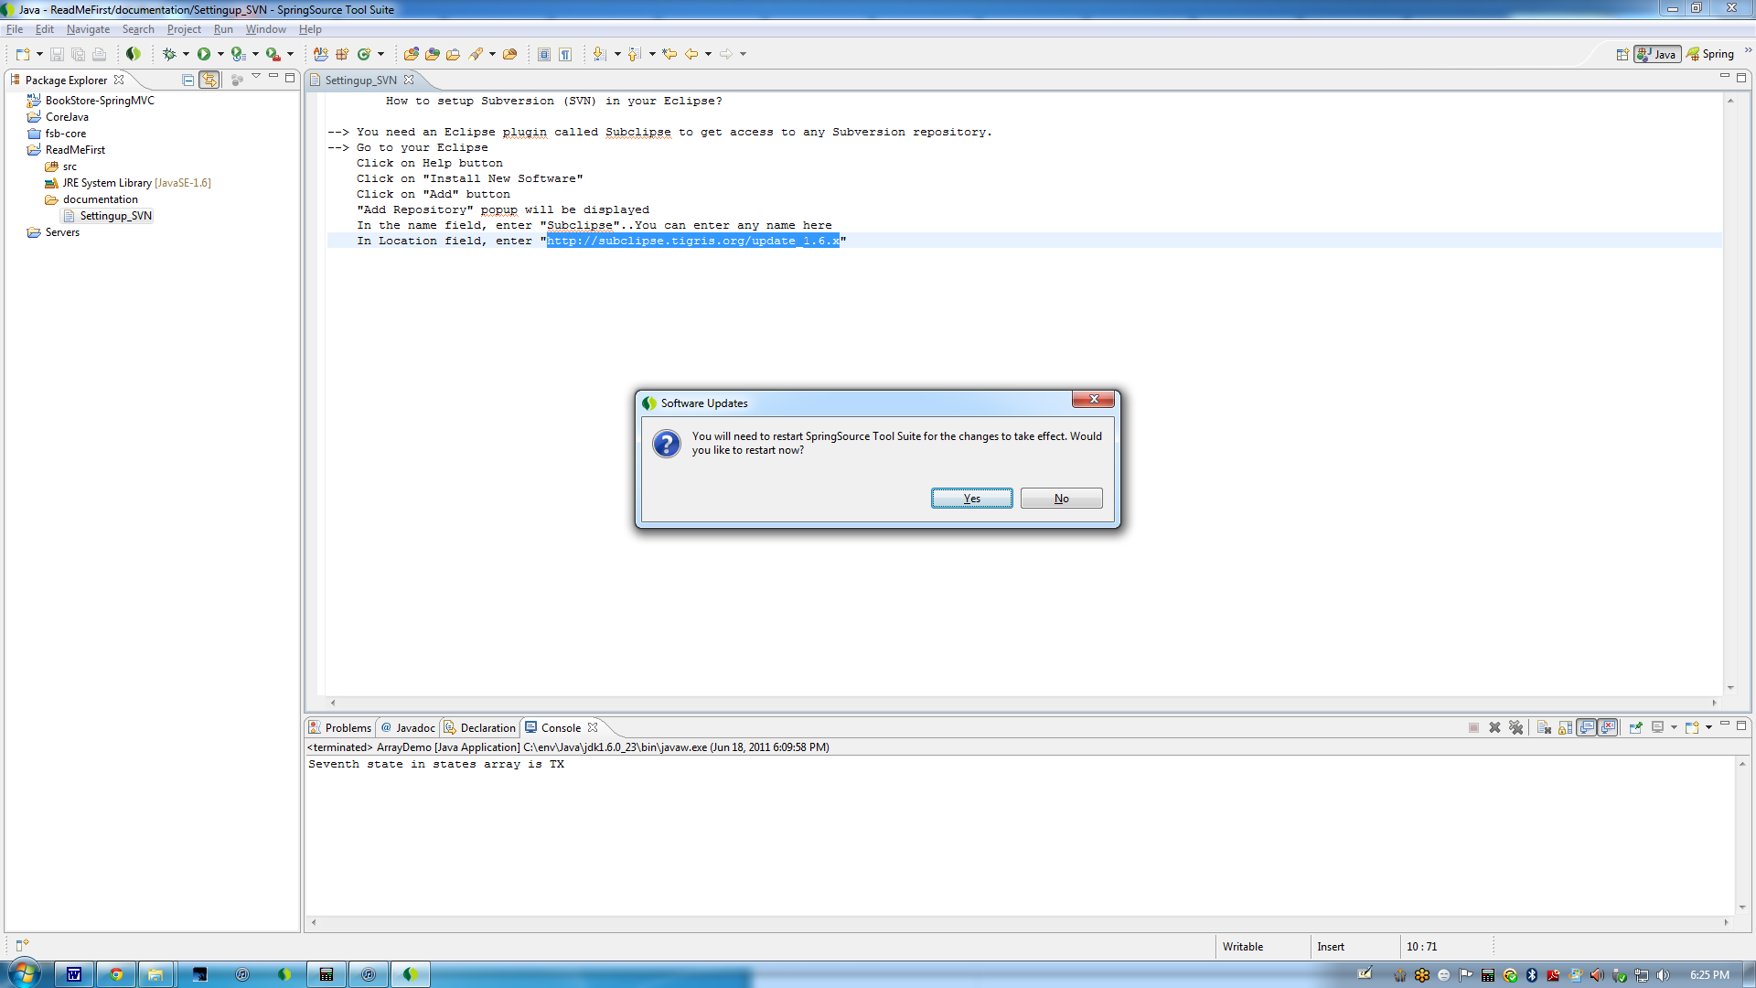

Now, Subclipse installation is complete..You may see the following screen, just click ok..

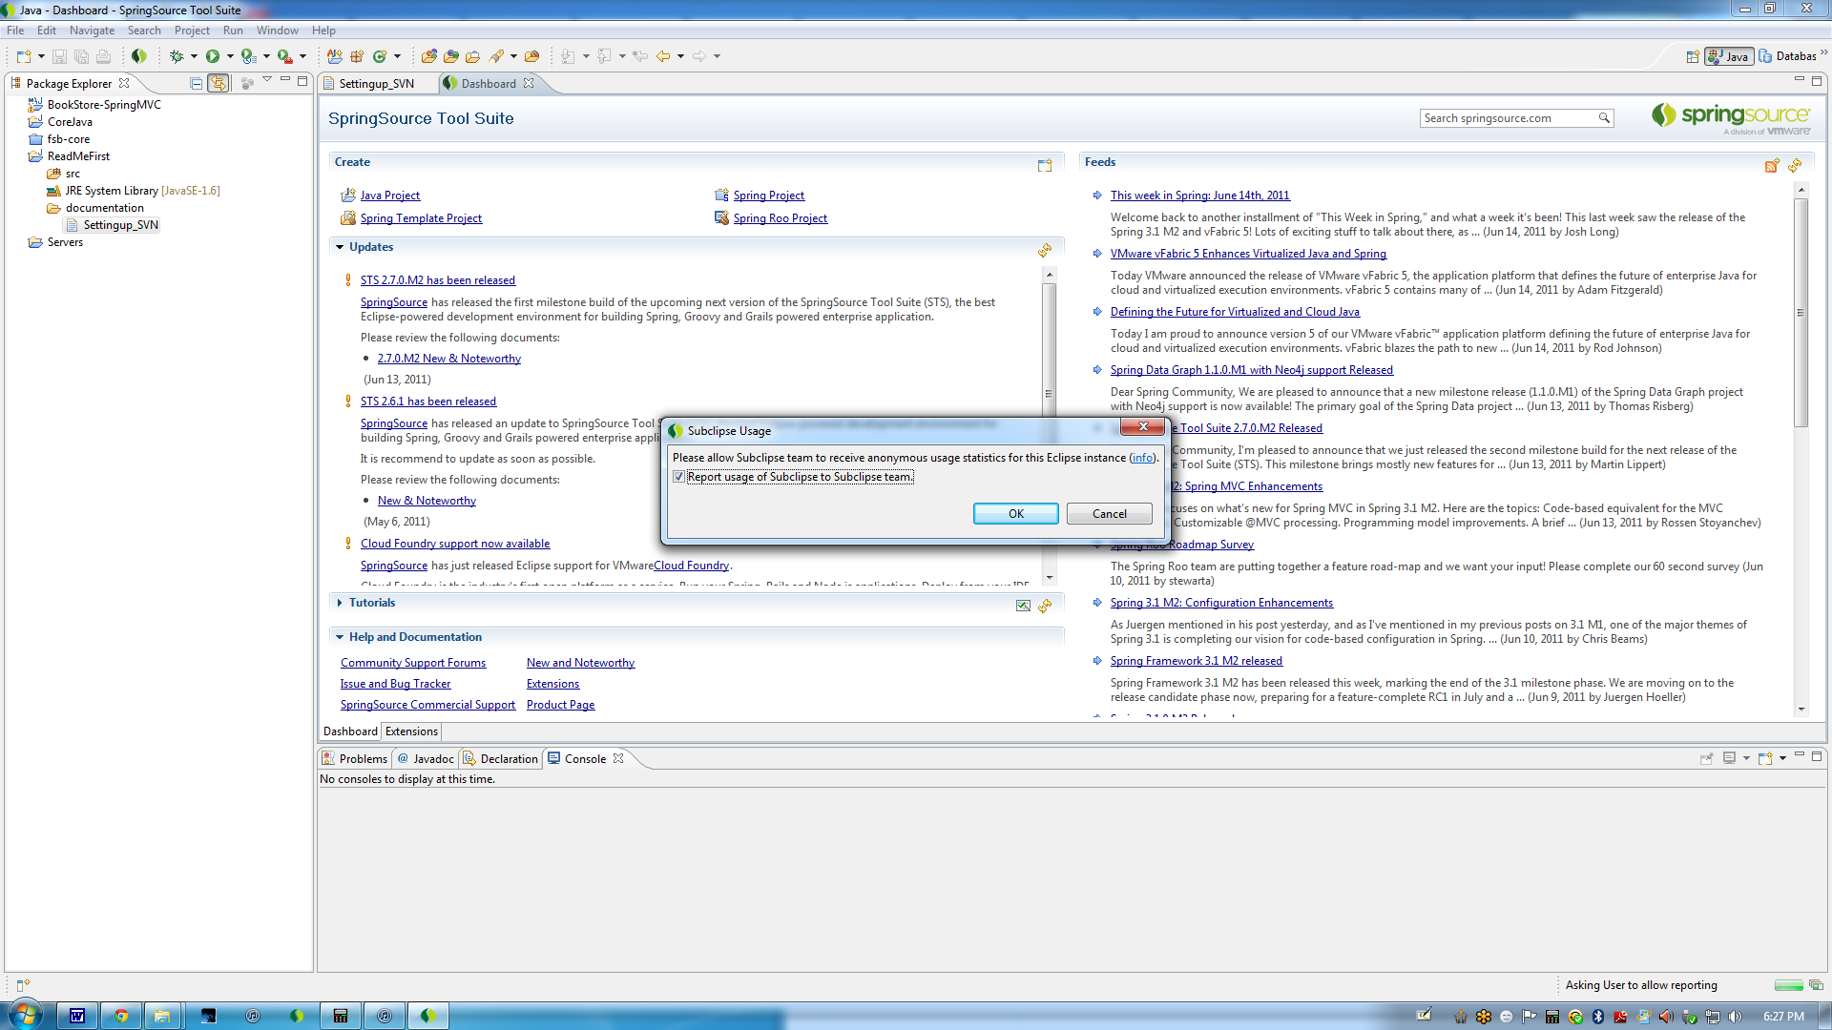

If you want to make sure it is properly installed, in your Eclipse, go to Window --> Open Perspective --> Other..You will see a new perspective there called "SVN Repository Exploring"..If you see this, your Subclipse plugin has been successfully installed.

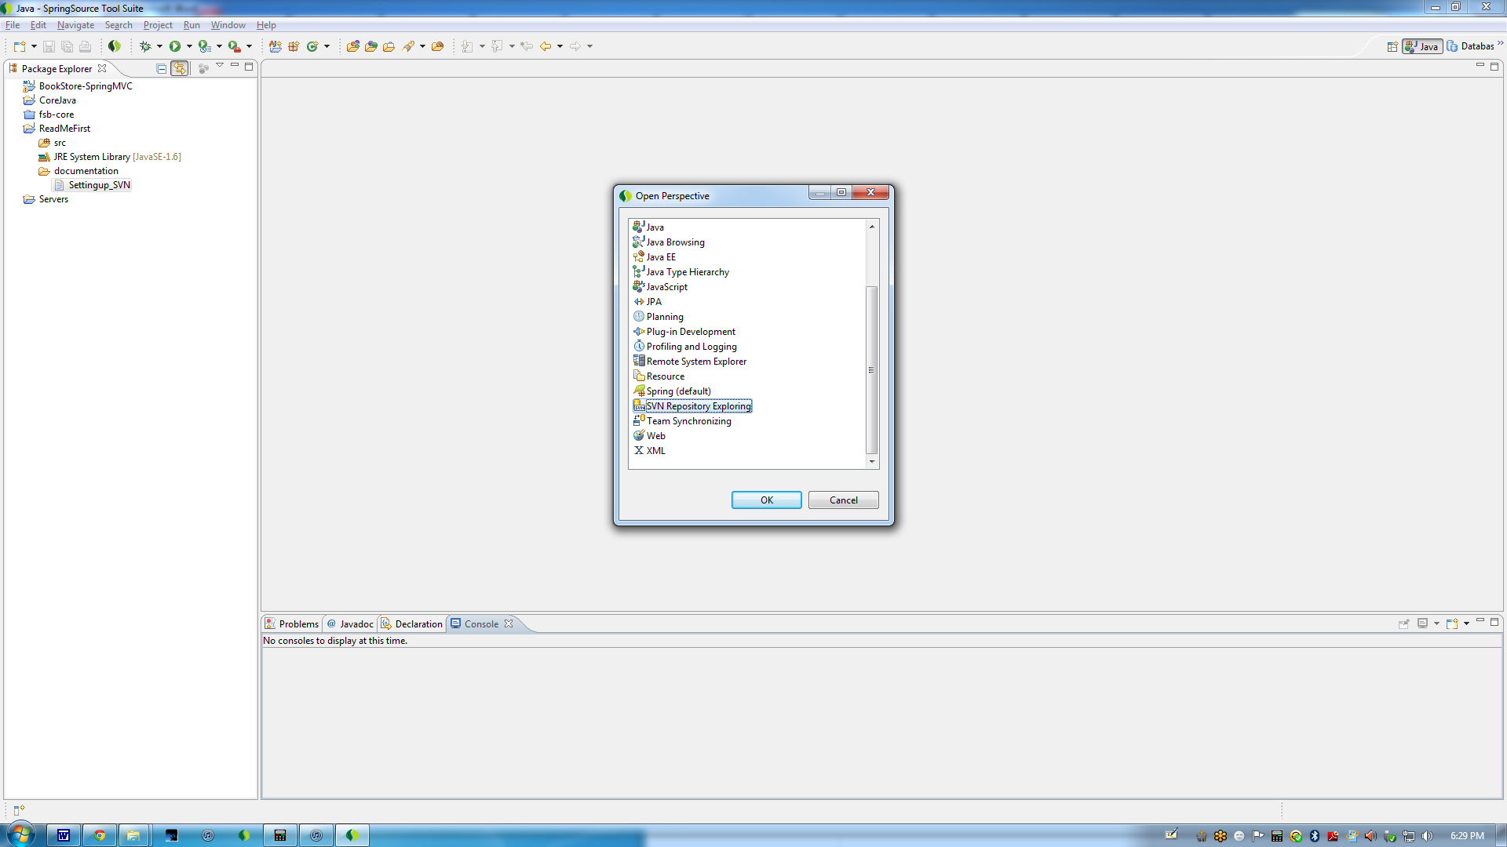

Now, to download the project from our repository, click on "SVN Repository Exploring" perspective..You will see a blank screen like below..

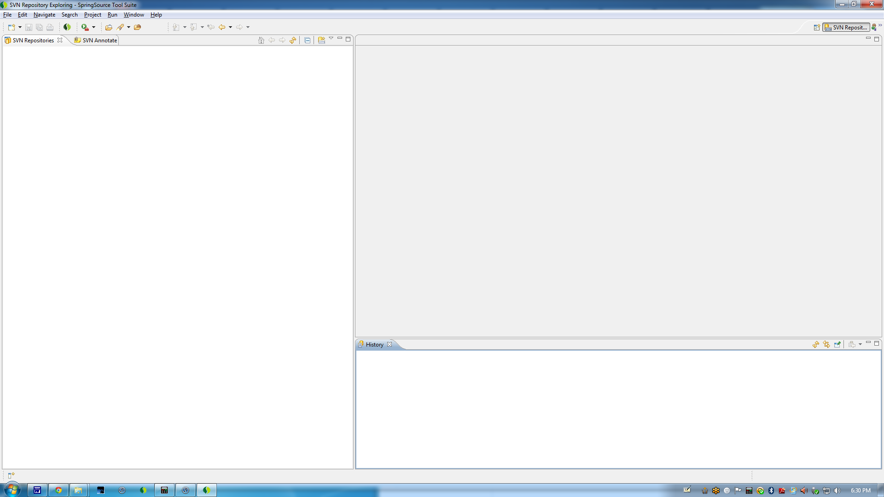

Now, on the left side, right click New --> Repository Location..You will see the following screen

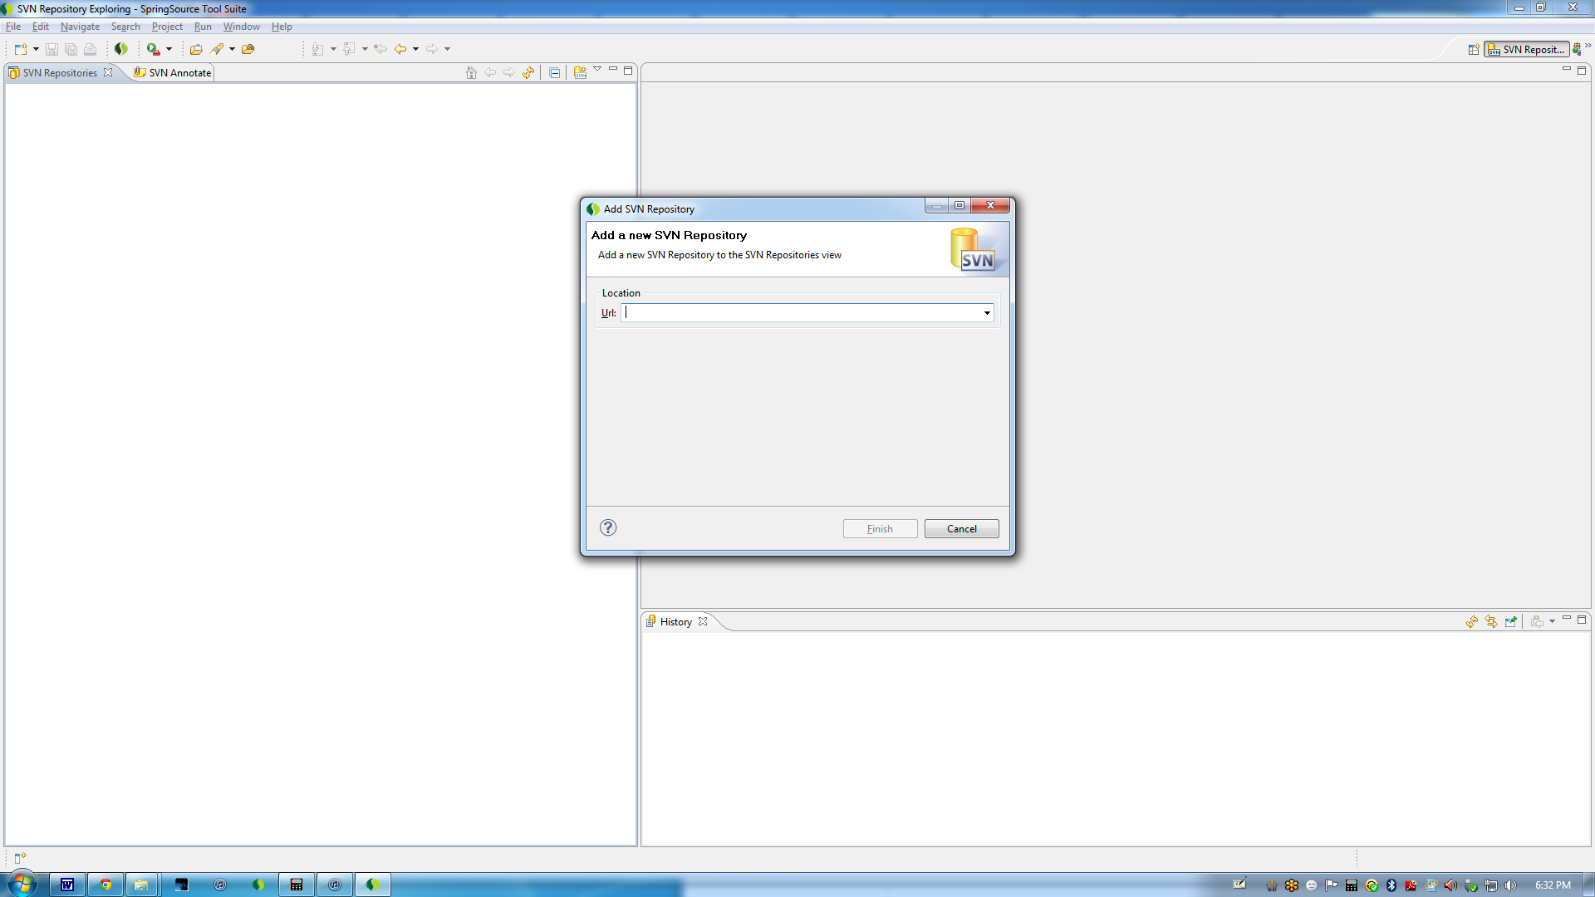

Here, you need to enter our repository URL which is
"http://java-training-venkat.googlecode.com/svn/trunk/"

Once you click on Done, you will see the following screen..click on that arrow button, you will see all the projects that I have uploaded so far...

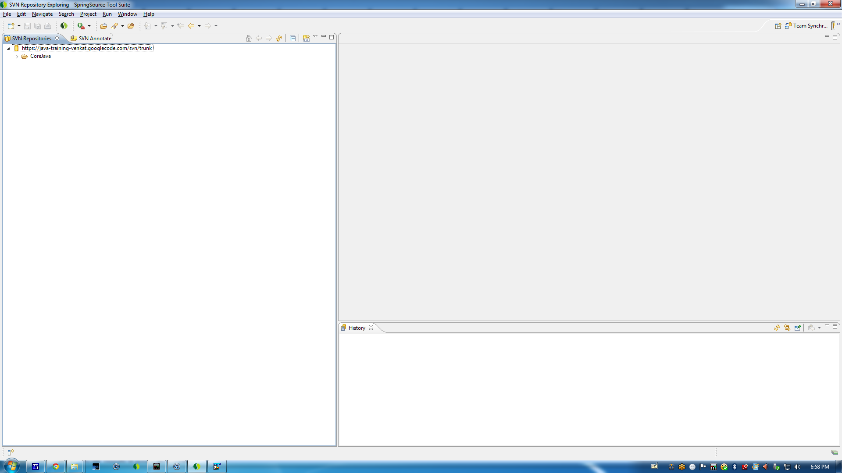

Right click on CoreJava project and click on "Check out" button..CoreJava project will be installed in your machine..Have fun with the code

